Tutorial 2
PreDCR Conversion of Commerical Drawing
(Parking + Ground + 3 Upper Floors + Mezzanine at First Floor with Stacked and Composite Parking)

How to convert the Commercial use PreDCR drawing for preparation of submission drawing?

- How to start PreDCR?
- Double-click the PreDCR Maharashtra_Print icon on your desktop.
- The following screen will pop up for the selection CAD version.
- Please select the CAD version to run the PreDCR.

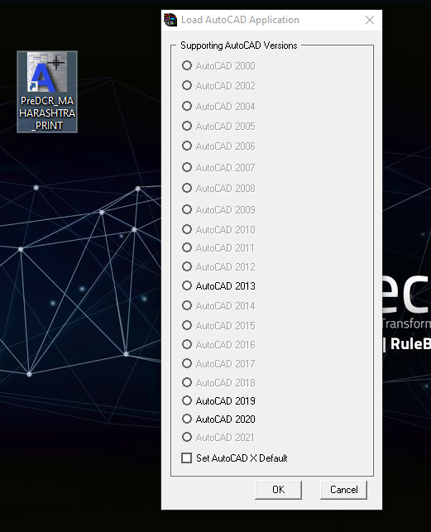

- PreDCR Toolbar and PreDCR Menu will be loaded in the CAD Application.

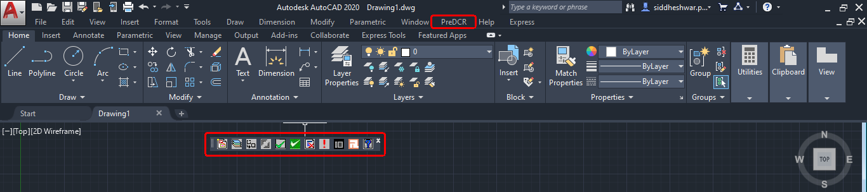
- How to create a ‘New Project’ and ‘Insert’ printing layout sheet?

- Open the drawing file form ‘Open File location’
- Click on the first tab available in the PreDCR toolbar ‘Create a new project for current drawing’.
- This command will ‘Create New project’ for the current drawing.
- ‘Project Information ‘window to select ‘Type of Project’ from the dropdown.
- Here, ‘Type of Project’ = ‘Building Development’ is selected.

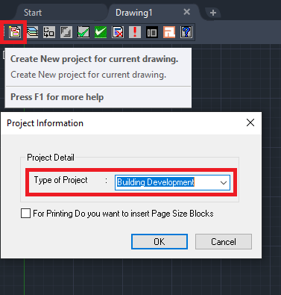

- Click ‘OK’ after selecting the type of project.

NOTE: All PreDCR conversion should be done in closed polylines on a 1:1 metric scale.

- How to Create Layers in the drawing?
- Click on the 2nd tab ‘Create DCR Layers in the current drawing’.
- This tab will create layers required for drawing conversion as per the selected ‘Type of Project’.
- Click on ‘Yes’ in the PreDCR dialog box.
- For the proposed development type software will generate the standard set of layers for drawing conversion.

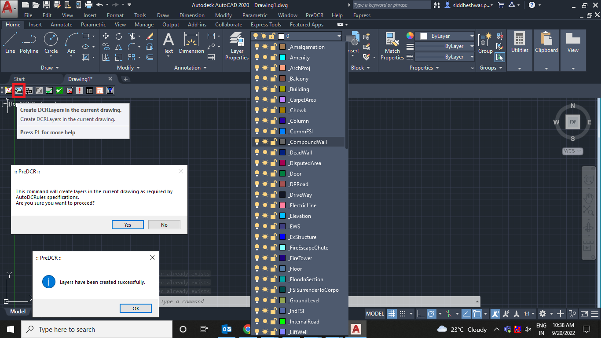

- How to convert PreDCR drawing?
Let’s learn the PreDCR drawing conversion.

This tutorial will explain the conversion process of a Commercial drawing with Parking + Ground + 3 Upper Floors + Mezzanine on First Floor with Stacked and Composite Parking.

  - Let’s start with the ‘Site Plan’ Conversion.

4.1.1. How to draw the ‘_MainPlot’ layer?
- Go to layers drop down Select ‘_MainPlot’ layer.
- Draw plot outline in closed polyline on the ‘_MainPlot’ layer.
- Give MText for ‘Plot Number/Name’.

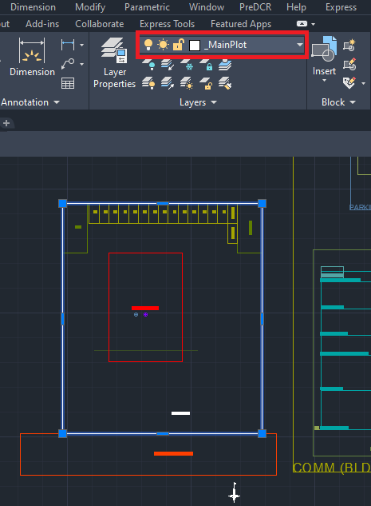

4.1.2. How to draw ‘_MainRoad’ layer?
- Go to layers drop down Select ‘_MainRoad’ layer.
- Draw main road in closed polyline on ‘_MainRoad’ layer.
- ‘_MainRaod’ layer should exactly overlap with ‘_MainPlot’ layer.
- Give MText for ‘Road name with road width’
For ex. Here in sample drawing – ‘18.00m Wide Main Road’ is written.
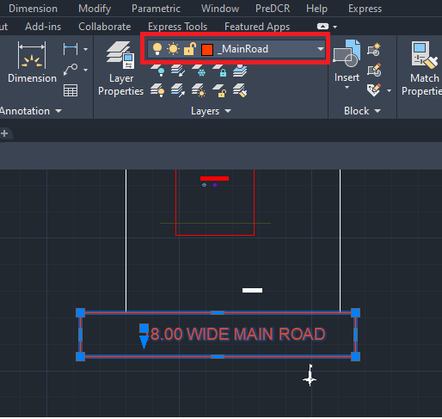

4.1.3. How to draw ‘_PWork’ layer?
- Go to layers drop down Select ‘_PWork’ layer.
- Draw proposed work/building outline in closed polyline on ‘_PWork’ layer.
- ‘_PWork’ layer should be drawn inside the plot poly.
- PWork is a building profile and shall be drawn inside the plot.

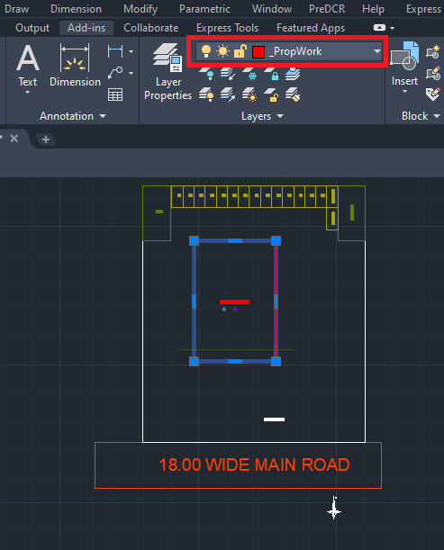

4.1.4. How to draw ‘Section line’ on PWork?

- Go to layers drop down Select ‘_Sectionline’ layer.
- Draw polying through the PWork on the ‘_Sectionline’ layer and give MText as ‘Section A-A’ as drawn in the drawing.

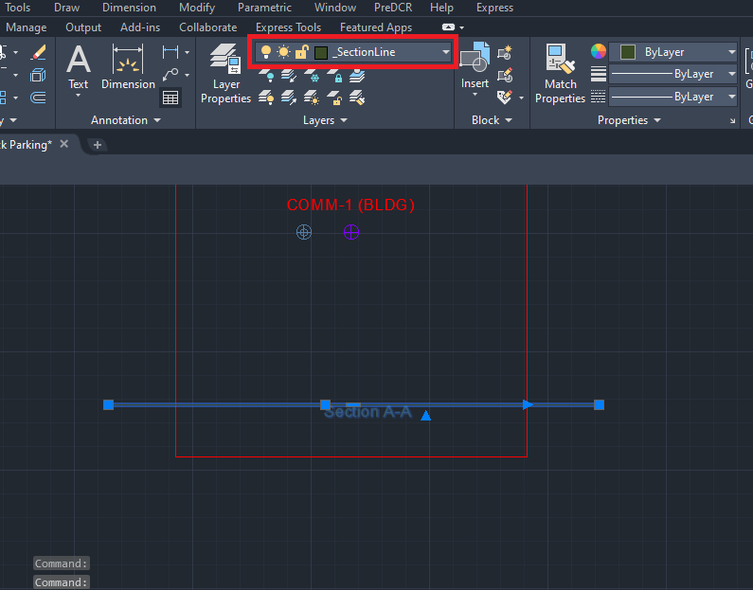

4.1.5. How to insert ‘Common reference circle’?
- Go to layers drop down Select ‘_FSI’ layer.
- For Residential proposal ‘_ResiFSI’ is selected.
- Select the ‘_ResiFSI’ layer to insert a common reference circle.
- Go to menu bar PreDCR menu drop down Select ‘Insert’ Select ‘Common reference circle.
- Common reference circle is mandatory to insert on the same point in every floor plan and in the site plan.
For ex: Select common space available on every floor like a staircase OR lift location

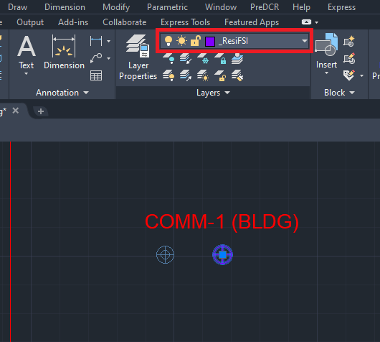

4.1.6. How to insert ‘Direction reference circle’?
- Go to layers drop down Select ‘_Floor’ layer.
- Select the ‘_Floor’ layer to insert the direction reference circle.
- Go to PreDCR menu drop down Select ‘Insert’ Select ‘Direction reference circle’.
- Direction reference circle is mandatory to insert at the same point in every floor plan and in the site plan.
For ex: Select common space available on every floor like a staircase OR lift location

Note:
Both direction and common reference circle are to be inserted together/next to each other at the same point.
Please refer to the below daring screenshot.

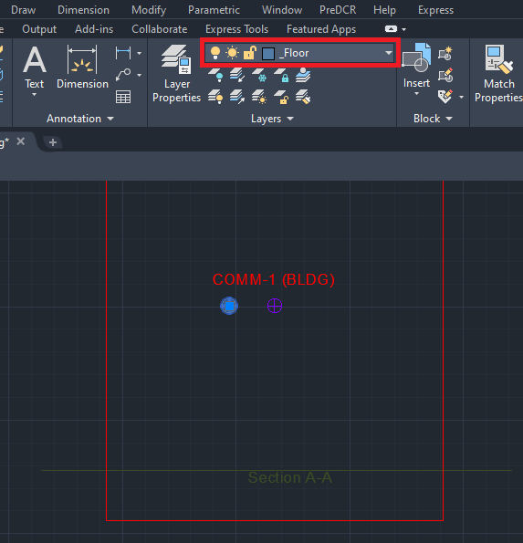

4.1.7. How to insert North Direction?
- Go to layers drop down Select ‘_Location Plan’ layer.
- To insert North Direction:
Go to the PreDCR menu Select ‘Insert’ Select ‘North Direction’ Specify Insertion
Point in the drawing.

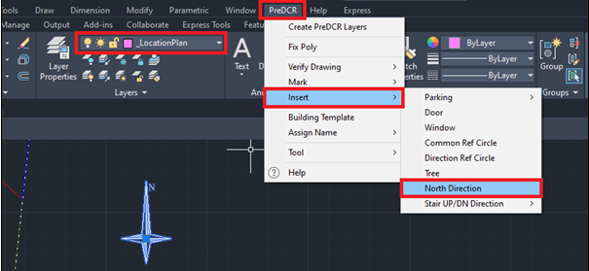

  - Let’s start the ‘Parking Floor Plan’ Conversion.

4.2.1. How to draw the parking floor outline on the ‘_Parking’ layer?
- Go to layers drop down Select ‘_Parking’ layer.
- Draw proposed parking outline in closed polyline on ‘_Parking’ layer.
- Give MText as ‘StiltParking’ OR ‘Parking’ as proposed.

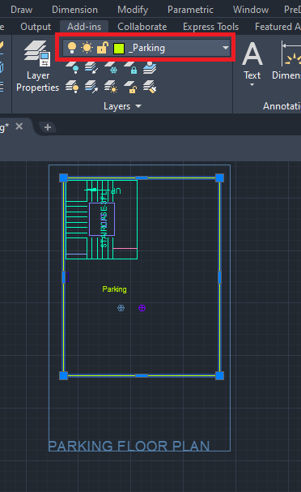

4.2.2. How to insert the individual car parking inside the parking floor?
- To insert the individual car parking :
Go to the PreDCR menu Select ‘Insert’ Select ‘Parking’ Select ‘Car’ Select ‘Small Car’ Select Floor/ Main Plot poly Specify insertion pointSpecify number for individual parking.
Insert car parking as per the proposal.

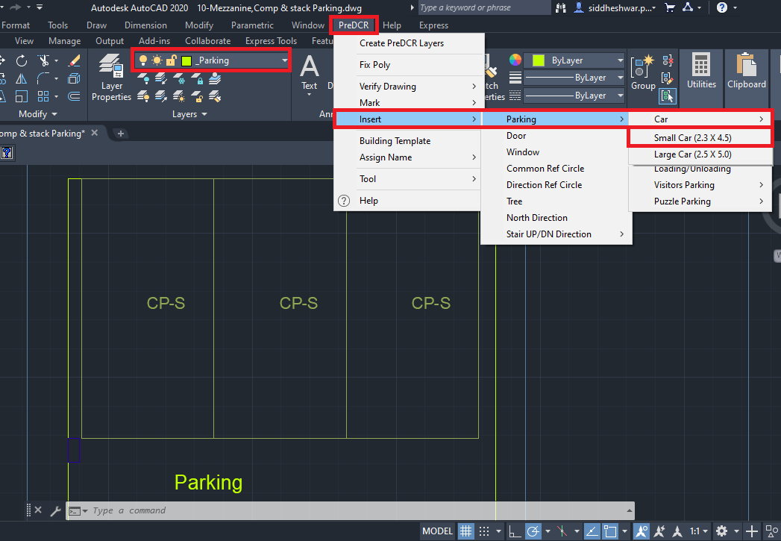

- How to mark individual inserted parking as ‘Stacked Parking’?
Go to the PreDCR menu Select ‘Mark’ Select ‘Parking’ Select ‘Two Stacked’ Select the individual parking poly which you want to mark stacked parking.
Marking options should be selected as per the proposal.
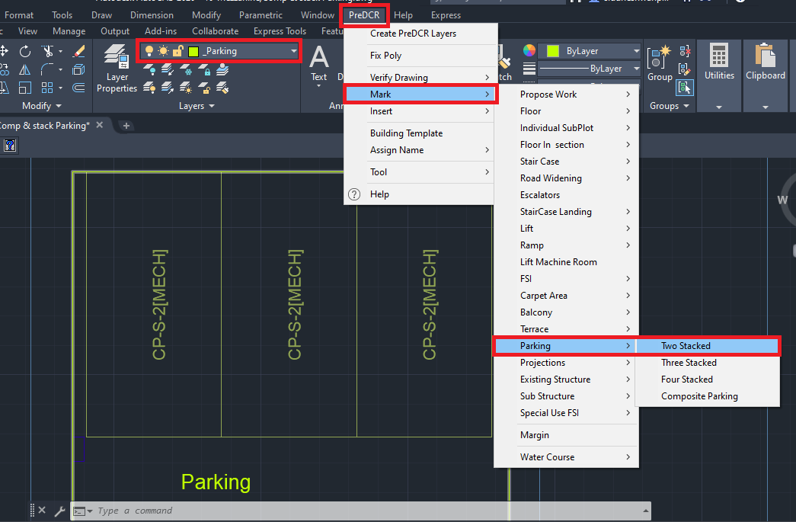

- How to mark individual inserted parking as ‘Composite Parking’?
Go to the PreDCR menu Select ‘Mark’ Select ‘Parking’ Select ‘Composite Parking’ Select the individual parking poly which you want to mark as ‘Composite Parking’

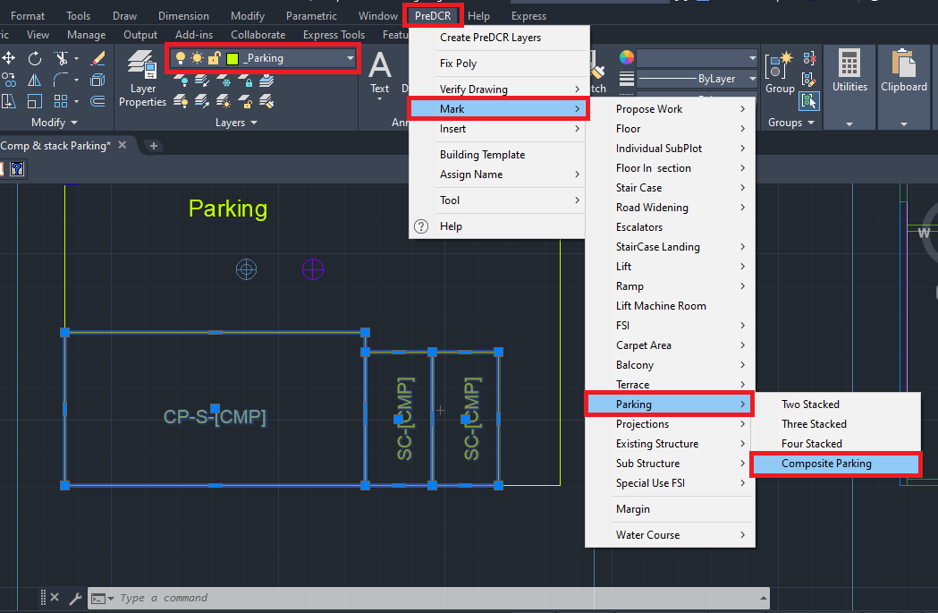

4.2.3. How to draw the ‘_LiftWell’ layer?
- Go to layers drop down Select ‘_LiftWell’ layer.
- Draw lift well on inner side in closed polyline on ‘_LiftWell’ layer.
- For marking of ‘_LiftWell’ layer:
Go to the PreDCR menu Select ‘Mark’ Select ‘Lift’ Select ‘Lift Default’.

Options available to mark the lift:
LiftLift Default.
LiftCar lift
LiftMRL
LiftHydraulic lift
LiftFire lift
LiftFireman lift
Select marking options as per requirement.

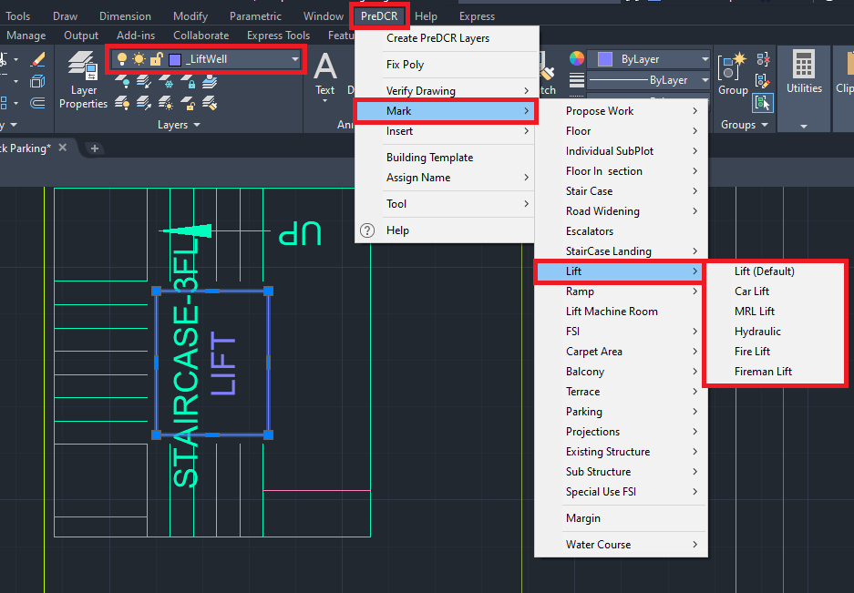

4.2.4. How to draw 3 flight staircase on ‘_Staircase’ layer?
- Go to layers drop down Select ‘_Staircase’ layer.
- Draw staircase block on the inner side in closed polyline on ‘_Staircase’ layer.
- ‘_Staircase’ poly should contain Intermediate Landing, Floor Landing & Each Tread as an open polyline.
- For marking of ‘_Staircase’ layer:
Go to the PreDCR menu Select ‘Mark’ Select StaircaseStaircase (Default)
Again Go to the PreDCR menu Select ‘Mark’ Select StaircaseNo of flight 3 Flight

Options available to mark the Staircase:
StaircaseNo of flight 3 Flight OR 4 Flight
StaircaseStaircase (Default)
StaircaseOpen Staircase
StaircaseFire escape staircase
StaircaseFab/Spiral stair
Select marking options as per requirement.
- For marking of staircase intermediate landing, flight width, and floor landing:
- Go to PreDCR menu Select ‘Mark’ Select ‘Staircase Landing’ Select ‘Intermediate landing’.
- Go to PreDCR menu Select ‘Mark’ Select ‘Staircase Landing’ Select ‘Flight Width’.
- Go to PreDCR menu Select ‘Mark’ Select ‘Staircase Landing’ Select ‘Floor Landing’.

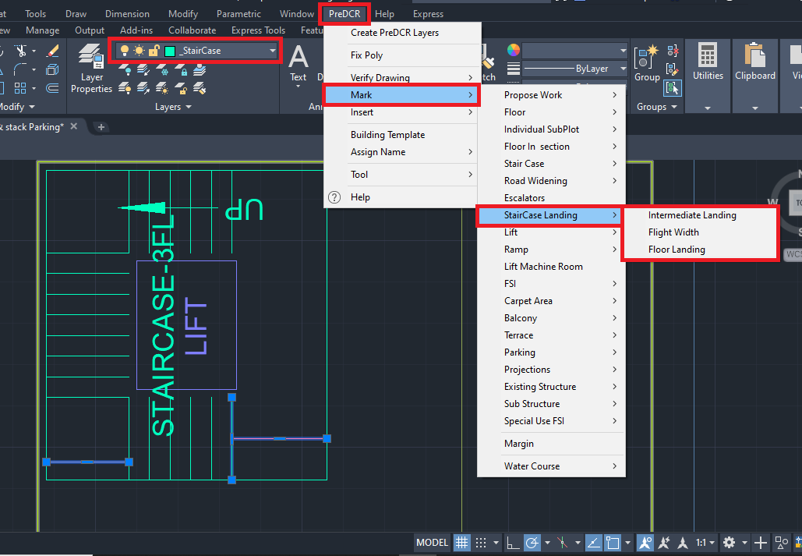

- To insert stair Up/DN direction:
Go to the PreDCR menu Select ‘Mark’ Select ‘Stair Up/DN’ Select ‘UP/DN’.

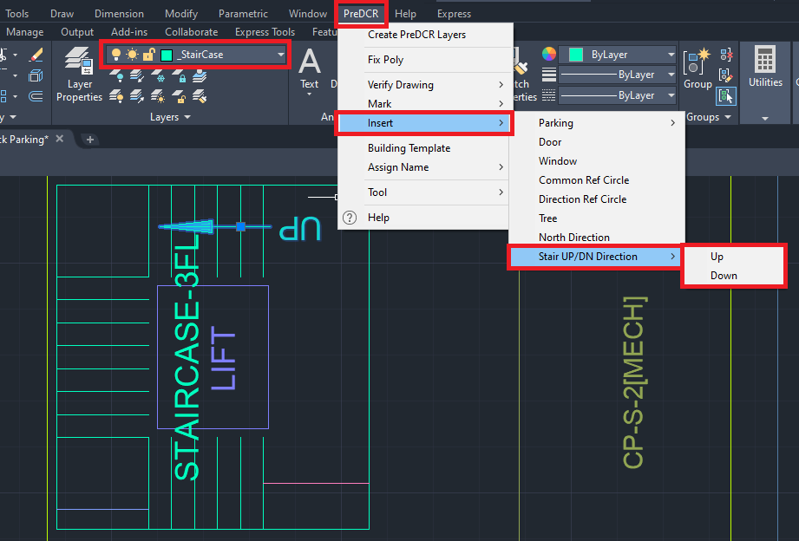

4.2.5. How to draw a parking floor plan on the ‘_Floor’ layer?
- Go to layers drop down Select ‘_Floor’ layer.
- Draw parking floor plan outline in closed polyline on the ‘_Floor’ layer.
- ‘_Floor’ layer poly should be drawn around the converted parking floor plan.

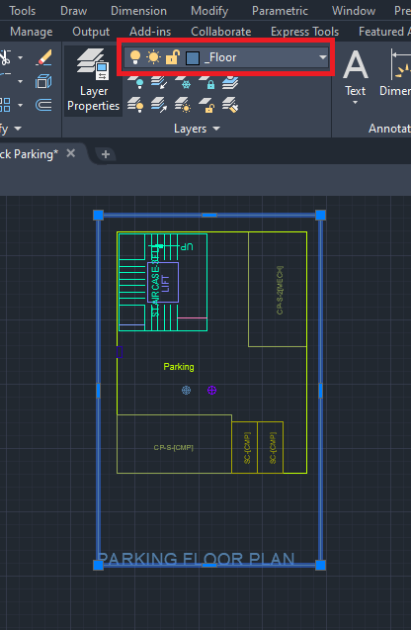

NOTE:
1) ‘Common Reference Circle’ and ‘Direction Reference Circle’ should be inserted in the PWORK on the ‘_FSI’ layer and ‘_Floor’ layer respectively in the same location as other floor plans.
Please refer to 4.1.5 and 4.1.6 sections to insert the common and direction reference circle on the parking floor.

  - Let’s start the First Floor & Upper Floor Plan Conversion.

4.3.1. How to draw a commercial floor plan on the ‘_CommFSI’ layer?
- Go to layers drop down Select ‘_CommFSI’ layer.
- Draw a commercial floor plan outline in a closed polyline on the ‘_CommFSI’ layer.
- For marking of ‘_CommFSI’ layer:
Go to the PreDCR menu Select ‘Mark’ Select ‘FSI’ Select ‘Normal (Default)’.
For the existing floor in case of addition/alteration case
Go to the PreDCR menu Select ‘Mark’ Select ‘FSI’ Select ‘Existing FSI’.

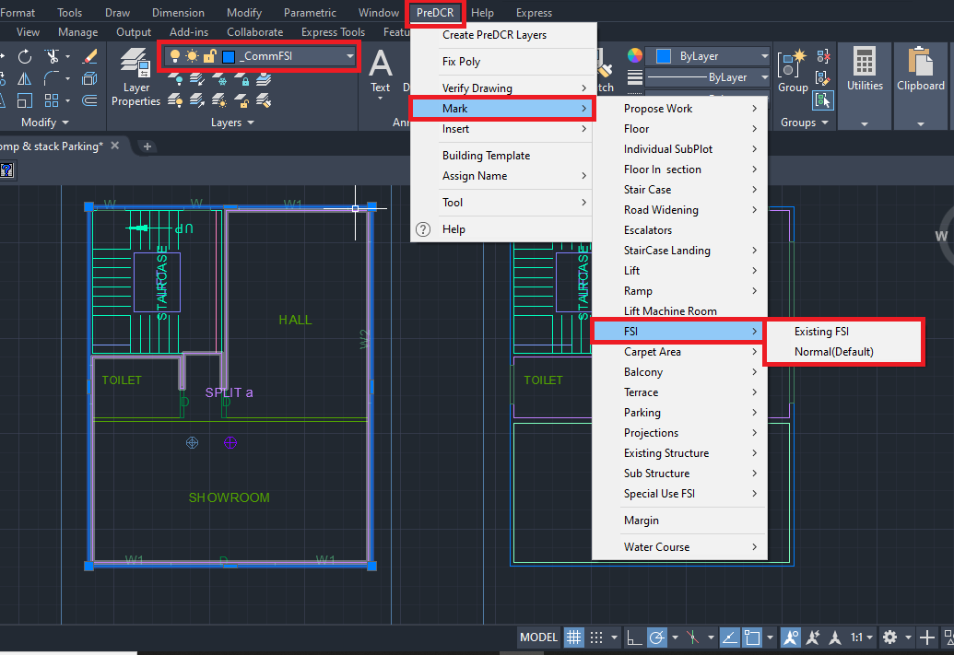

4.3.2. How to draw ‘_Room’ layer?
- Go to layers drop down Select ‘_Room’ layer.
- Draw every room in closed polyline on ‘_Room’ layer.
- To assign ‘Room’ name ‘_Room’ layer:
Go to the PreDCR menu Select ‘Assign Name’ Select ‘Room’ use name From the list of room names For ex: Select Showroom/Toilet/Hall.
As per the proposed plan.
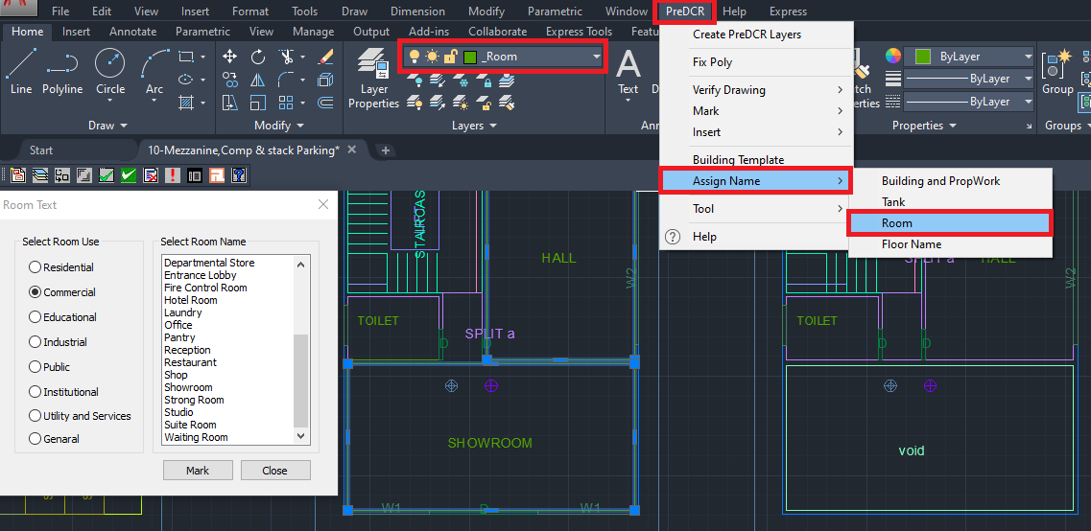

4.3.3. How to draw the ‘_CarpetArea’ layer?
- Go to layers drop down Select ‘_CarpetArea’ layer.
- Draw carpet outline in closed polyline on the ‘_CarpetArea’ layer.
- ‘_CarpetArea’ layer represents the carpet area of the tenement/dwelling unit area.
- For marking the‘_CarpetArea’ layer:
Go to the PreDCR menu Select ‘Mark’ Select ‘Carpet Area’ Select ‘Normal (Default)’.
To give tenement numbers OR name (Ex. GF, FF, SF OR Use of Floor…) edit carpet text.
Options available to mark the Carpet Area:
Go to menu bar PreDCR MarkCarpet Area Splited Tenement
Go to menu bar PreDCR MarkCarpet Area Slum development Rehab OR Sale
Go to menu bar PreDCR MarkCarpet Area Normal (Default).

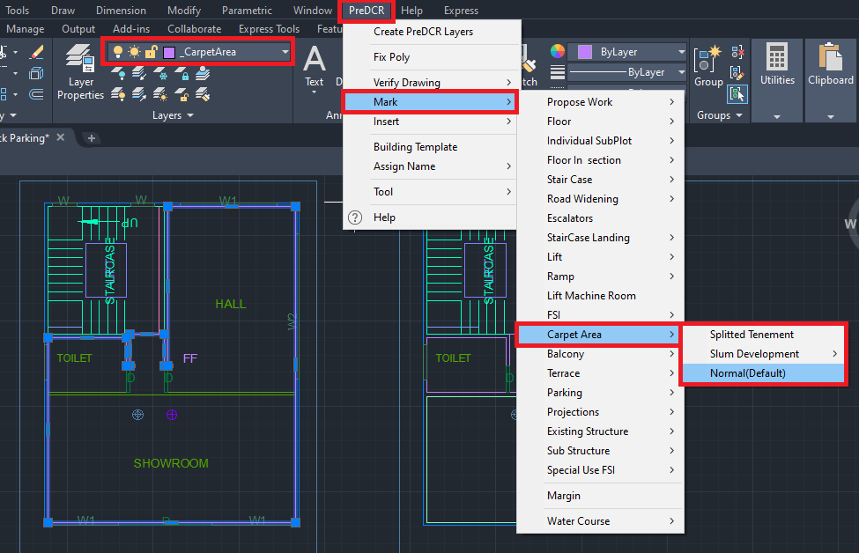

4.3.4. How to insert the door on ‘Door’ layer?
- Go to layers drop down Select ‘Door’ layer.
- To insert doors on the ‘Door’ layer:
Go to the PreDCR menu Select ‘Insert’ Door.

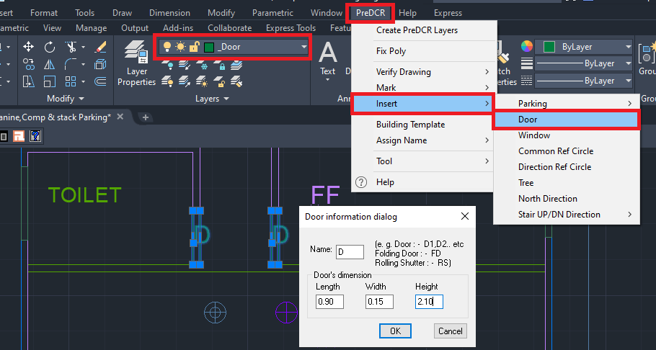

- In the ‘Door Information Dialog’ box fill up the information:
For ex: ‘Width’=0.90m, ‘Depth’=0.15m, ‘Height’ =2.10m and ‘Name’ = D as shown.
Insert the door as per the requirement
Similarly, insert ‘Rolling Shutter’ and fill up information in the dialog box as per the proposal:
For ex: ‘Width’=2.70m, ‘Depth’=0.15m, ‘Height’ =2.10m and ‘Name’ = R/S.
For rolling shutter in ‘Name’ = ‘R/S’ is fill up instead of ‘D’.

4.3.5. How to insert a window on the ‘_Window’ layer?
- Go to layers drop down Select ‘_Window’ layer.
- To insert doors on the ‘_Window’ layer:
Go to the PreDCR menu Select ‘Insert’ Select ‘Window’.
Fill up window information in a dialog box:
For ex: ‘Width’ = 1.80m, ‘Depth’=0.15m, ‘Height’=1.80m and ‘Name’ =W1.
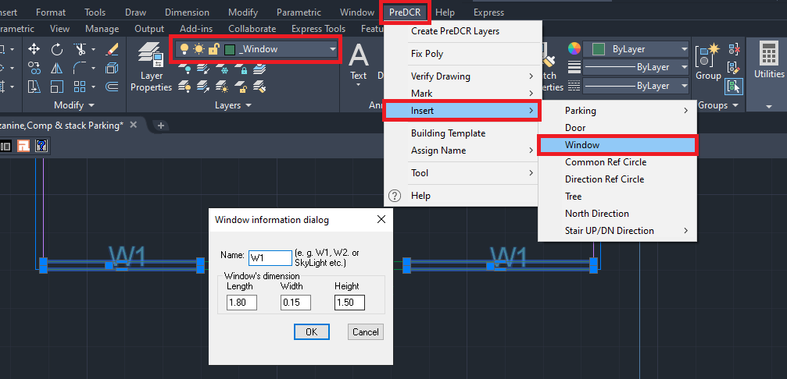
Similarly, insert ‘Ventilator’ and fill up the information as per requirement.
For ex: ‘Width’ = 0.60 m, ‘Depth’=0.23m, ‘Height’=1.20 m and ‘Name’ = V as shown.
For ventilator in ‘Name’ = ‘V’ is filled up instead of ‘W’.

4.3.6. How to draw a floor plan inside the ‘_Floor’ layer?
- Go to layers drop down Select ‘_Floor’ layer.
- Draw floor plan outline in closed polyline on the ‘_Floor’ layer.
- ‘_Floor’ layer poly should be drawn outside/all around the converted floor plan.
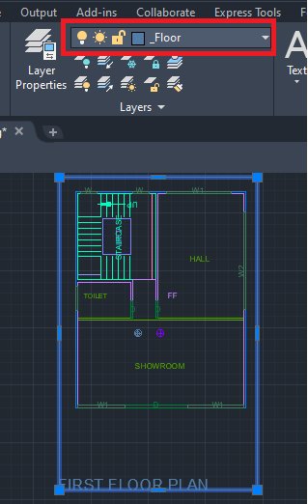
NOTE:
- ‘Common Reference Circle’ and ‘Direction Reference Circle’ should be inserted in the PWORK plan on the ‘_FSI’ layer and ‘_Floor’ layer respectively in the same location as of other floor plans. please refer 4.1.5 and 4.1.6 sections to insert the common and direction refernace circle on rest upper floors plans.
- Complete the floor plan by converting the staircase block and lift well as explained in the 4.2.3 and 4.2.4 sections. Similarly, convert the remaining floor plans.

4.3.7. How to convert mezzanine floor?
- Convert mezzanine floor same like other habitable floor in seperat floor poly.
- Here in sample drawing mezzanine floor is proposed on first floor, First floor double height up to mezzanine floor draw a as follow:
- Go to layers drop down Select ‘_Void’ layer.
- Draw a open space between first floor to mezzanine floor on mezzanine floor, in closed poly on ‘_Void’ layer and give MText as ‘Open to First Floor OR First Floor Double Height’.

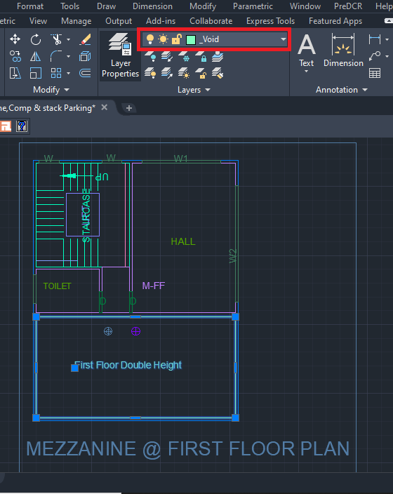

4.3.8. How to draw a terrace floor on the ‘_Terrace’ layer
- Go to layers drop down Select ‘_Terrace’ layer.
- Draw terrace floor plan outline in closed polyline on the ‘_Terrace’ layer.
- For marking of ‘_Terrace’ layer:
Go to the PreDCR menu Select ‘Mark’ Select ‘Terrace’Common Terrace/ Individual
Terrace.

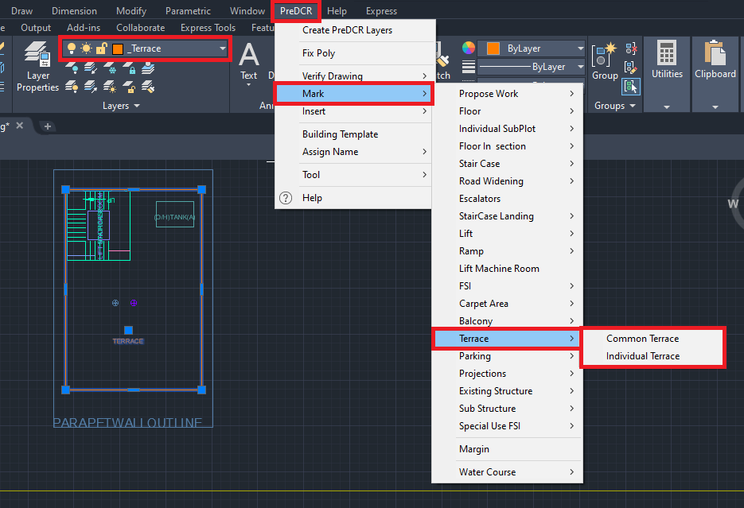

4.3.9. How to draw Over Head Water Tank (OHWT) on the terrace floor on ‘_Tank’ layer?
- Go to layers drop down Select ‘_Tank’ layer.
- Draw OHWT on the terrace floor plan in closed polyline on the ‘_Tank’ layer.
- To Assign Name to ‘_Tank’ layer:
Go to PreDCR menu Select ‘Assign Name’ Select ‘Tank’
Fill up the Tank name information dialog box:
For ex: ‘Tank position’= Overhead, ‘Tank name/no’=OHWT-1
Similarly, assign name for ‘Unground Tank Water Tank ‘:
Go to PreDCR menu Select ‘Assign Name’ Select ‘Tank’
Fill up the Tank name information dialog box:
For ex: ‘Tank position’= Underground, ‘Tank name/no’=UGWT-1

OHWT-A in Terrace Floor Plan OHWT-A in Section A-A
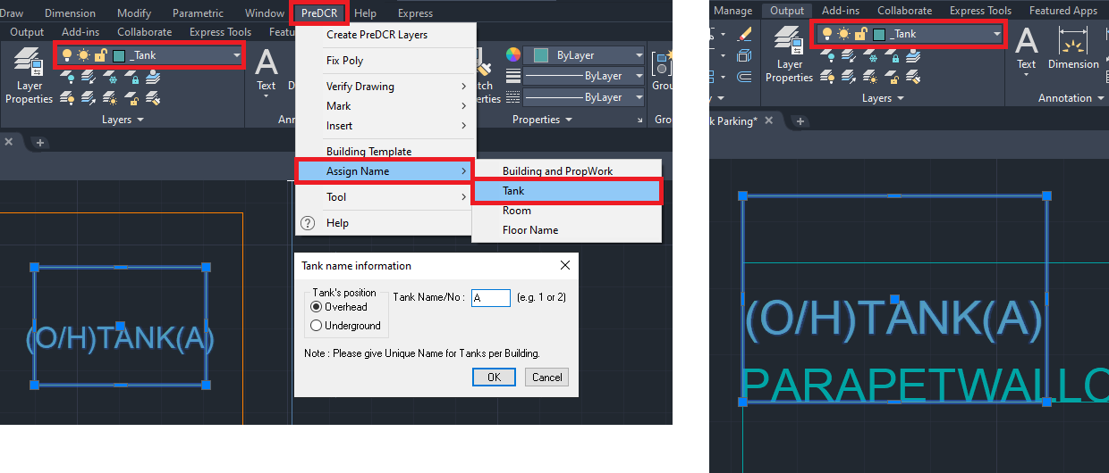

Note: After adding tank information in the dialog box, to assign a name select both ‘_Tank’ polyline drafted in the ‘Floor Plan’ and in ‘Section A-A block for assigning.

4.3.10. How to draw lift machine room ‘_LiftWell’ layer?
- Go to layers drop down Select ‘_LiftWell’ layer.
- Draw lift machine room in closed polyline on ‘_LiftWell’ layer.
- For marking of ‘_LiftWell’ layer:
Go to PreDCR menu Select ‘Mark’ Select ‘Lift Machine Room’ Select both lifts well
poly drafted in ‘Floor Section’ and ‘Terrace Floor Plan’.

Lift machine room on Terrace Floor Lift machine room in Secation A-A
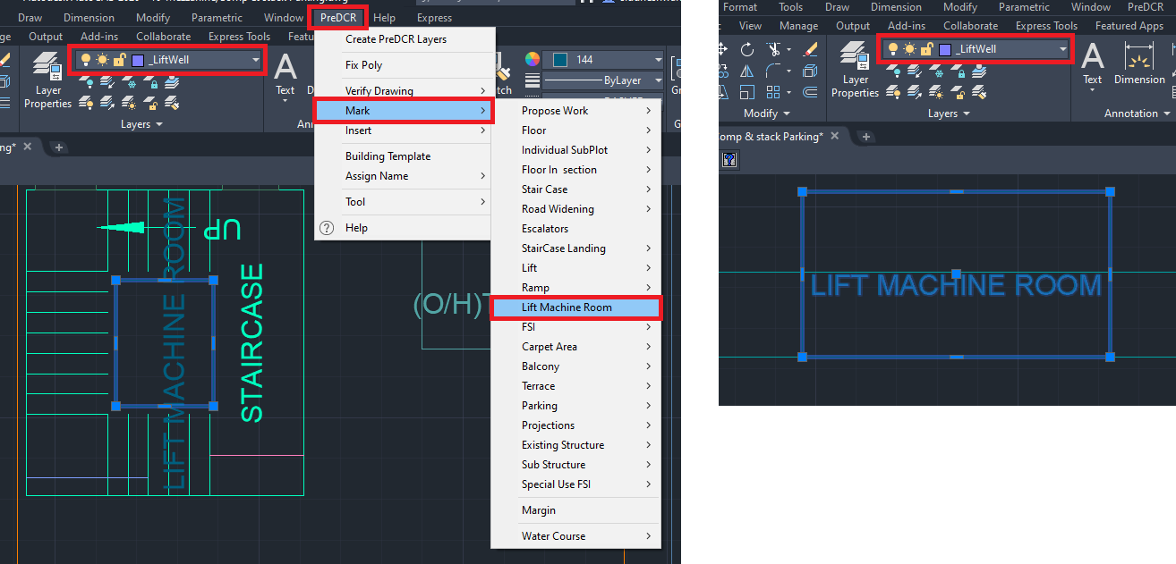

NOTE:
- Completeete the floor plan by converting the staircase block.
Please refer to 4.2.4 to draw a staircase on the terrace floor.
- ‘Common Reference Circle’ and ‘Direction Reference Circle’ should be inserted in the PWORK plan on the ‘_FSI’ layer and ‘_Floor’ layer respectively in the same location as of other floor plans. please refer to 4.1.5 and 4.1.6 sections to insert the common and direction reference circle on the rest upper floor plans.

  - Let’s start the Floor Section Conversion.

4.4.1. How to draw the floor section on the ‘_FloorInSection’ layer?
- Go to layers drop down Select ‘_FloorInSection’ layer.
- Draw each and every floor in closed polyline on the ‘_FloorInSection’ layer separately.

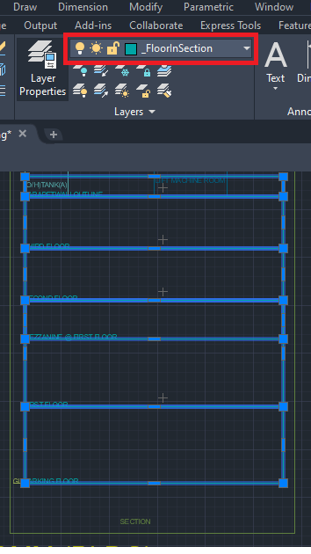

- How to draw a Mezzanine floor section on ‘_FloorInSection’ layer:
- Draw mezzanine floor in closed polyline on ‘_FloorInSection’ on the repetive floor in ‘FloorInSection’ block which has proposed the mezzanine floor.

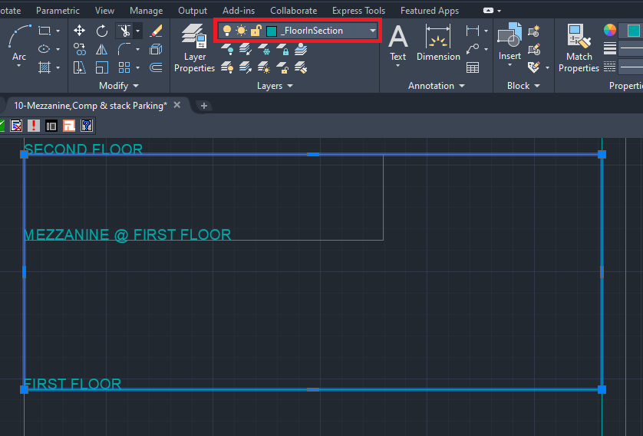

4.4.2. How to link floor section and floor plans?

To link the floor in section to floor in the plan.
Go to PreDCR Menu Select ‘Assign Name’ Select Floor Name/Nos.
Fill in the information in the ‘Auto Assign floor name’ dialog’ box:
‘Select floor name’ from a drop-down (for ex: Ground Floor)
Select ‘OK’, then select the corresponding floor poly on the floor and section block, in the drawing Parking Floor Plan is selected in the plan and section block.

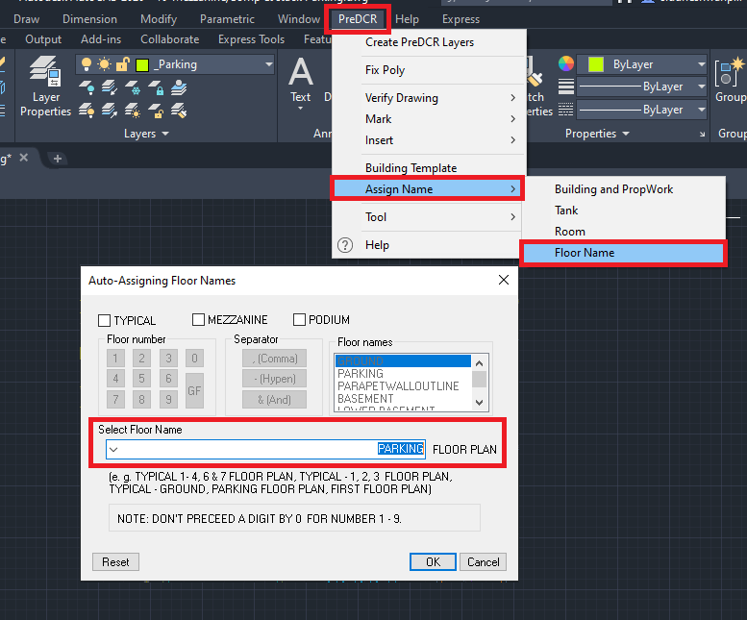
After that system automatically assigns selected floor poly and floor in section poly as per the assigned name as follow:
Floor Plan Section
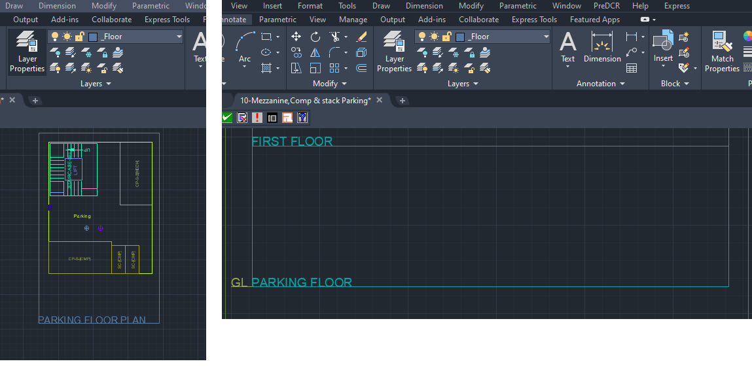

- To assign typical floor poly with the floor in section poly follow the process as follows:
Fill in the information in the ‘Auto Assign floor name’ dialog’ box:
Select the check box of ‘Typical’
Add the number of typical floors (like 1,2 & 3)
Select ‘OK’
Select floor poly of the corresponding floor
Select one by one typical floor in section poly
The floor Plan will be automatically linked with the Section Floor by matching the Floor Name.

- To assign terrace floor with the floor in section poly follow the process as follows:
Fill in the information in the ‘Auto Assign floor name’ dialog’ box:
‘Select floor name’ from a drop-down (for ex: Terrace floor)
Select ‘OK’, then select the corresponding terrace floor poly, and in section block select the floor in section poly
The floor Plan will be automatically linked with the Section Floor by matching the Floor Name.

- To assign a mezzanine floor with the floor in section poly follow the process as follows:
Fill in the information in the ‘Auto Assign floor name’ dialog’ box:
Select the check box of ‘Typical’
Add number of floor which has proposed mezzanine floors (like Mezzanine @ First)
Select ‘OK’
Select floor poly of the mezzanine floor
Select mezzanine floor floorinsection poly from section block

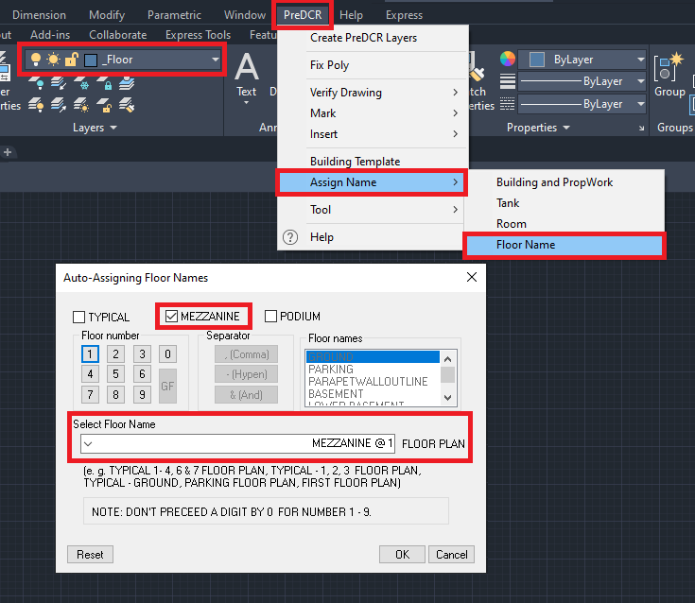
The mezzanine floor plan will be automatically linked with the mezzanine floor in section poly in the section by matching the Floor Name.

Mezzanine @ First Floor (Plan) Mezzanine @ First Floor (Section A-A)
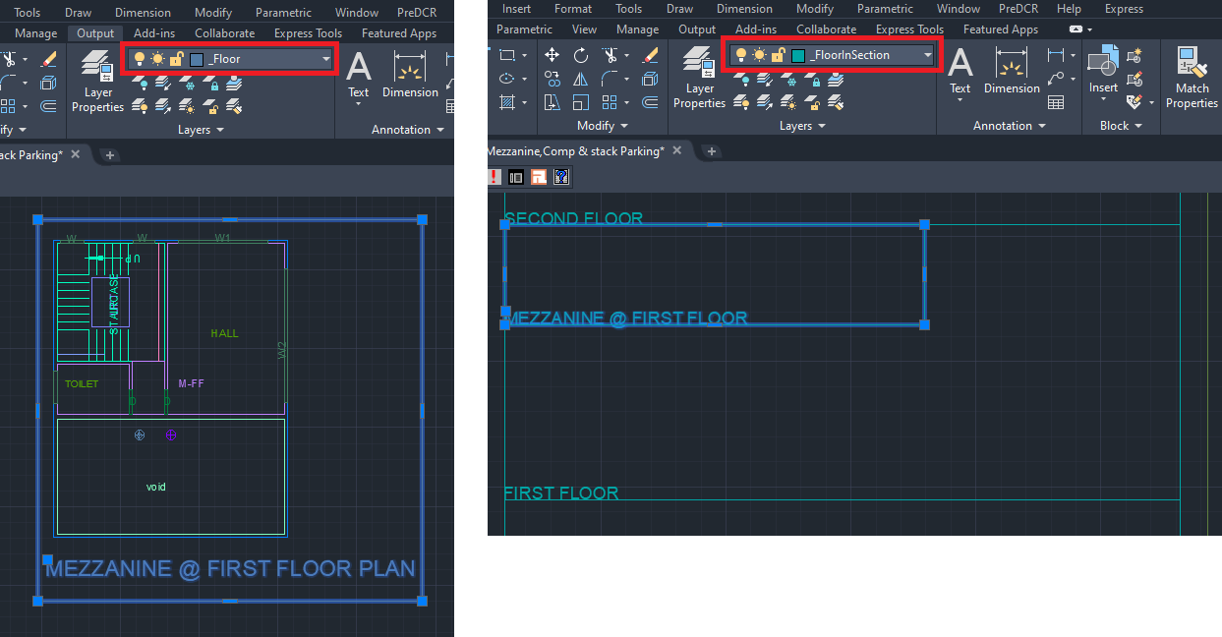

4.4.3. How to draw staircase headroom in the ‘_Staircase’ layer?
- Go to layers drop down Select ‘_Staircase’ layer.
- Draw staircase headroom in closed polyline on the ‘_Staircase’ layer.
- Give the MText as ‘Staircase OR Staircase Head Room’.

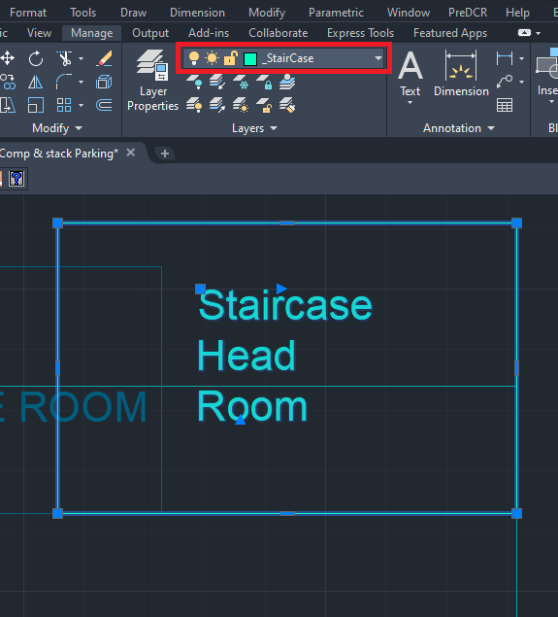

Note:
- Complete the floor plan by converting the lift machine room.
Please refer to 4.3.10 to draw a lift machine room and marking.

4.4.4. How to draw ground level in the ‘_GroundLevel’ layer in Floor Section?
- Go to layers drop down Select ‘_GroundLevel’ layer.
- Draw the ground level in polyline on ‘_GroundLevel’ layer.
- Give ‘MText’ as ‘Ground Level ‘.

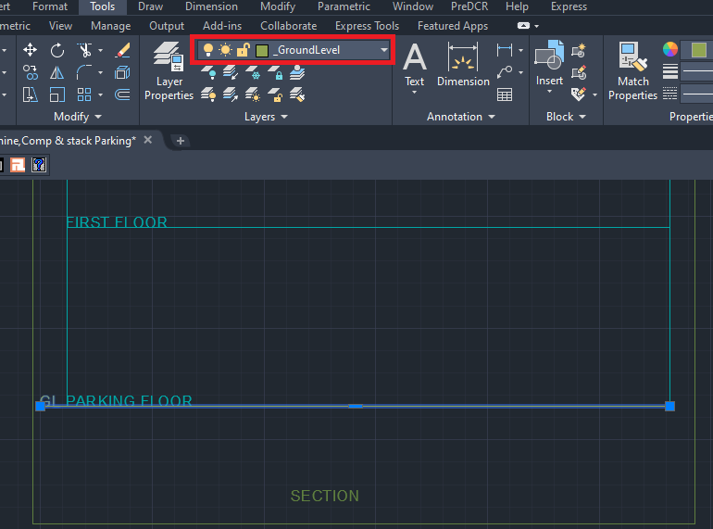

4.4.5. How to draw section details ‘_Section’ layer?

- Go to layers drop down Select ‘_Section’ layer.
- Draw ‘_Section’ layer poly to group all floors in section, lift machine room, staircase head room and tank details.
- Give ‘MText’ as ‘Section A-A‘ as per the drawing.

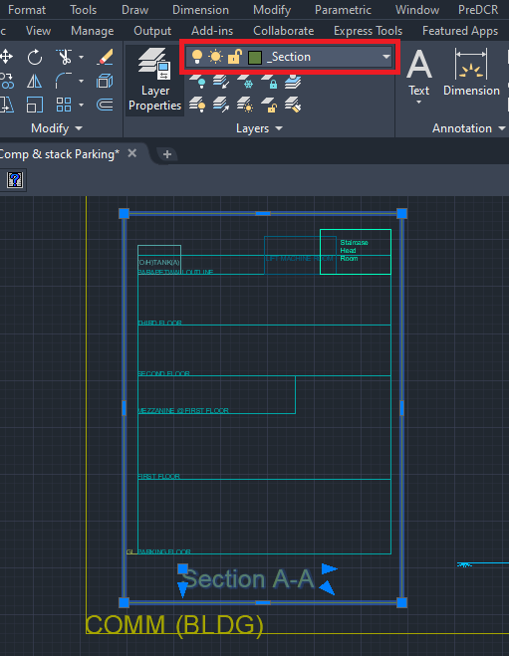

4.4.6. How to draw print additional details items in the ‘_PrintadditionalItem’ layer?
- Go to layers drop down Select ‘_PrintadditionalItem’ layer.
- Draw all architectural details (like Septic tank details, RWH Details, and Compound Wall Details) on the ‘_PrintAddtionalDetail’ layer.

4.4.7. How to draw elevation on the ‘_Elevation’ layer?
- Go to layers drop down Select ‘_Elevation’ layer.
- Draw every side elevation on ‘_Elevation’ layer OR you can can change elevation layer architecural layer to PreDCR ‘_Elevation’ layer.
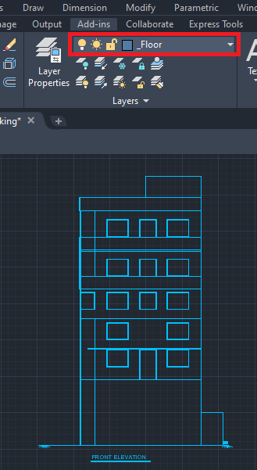

4.4.8. How to draw floor plans, sections, elevation, and print additional details inside the ‘_Building’ layer?
- Go to layers drop down Select ‘_Building’ layer.
- Draw ‘_Building’ layer poly to group all floor plans, section, elevation and print additional details of the same Building.

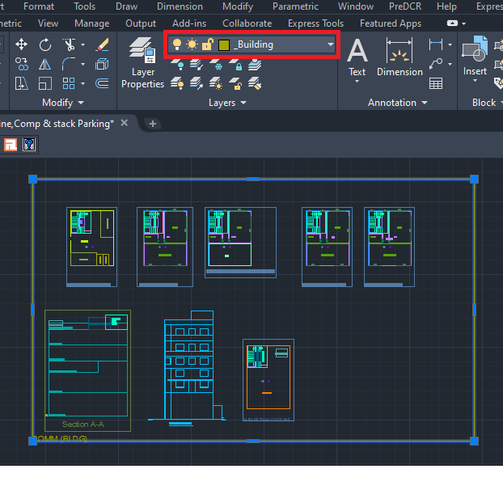

4.4.9. How to link the building plan to PWork?
- To link building plan to Pwork.
Go to PreDCR menu-Select ‘Assign name’ Building and Prop work.
Select ‘Building poly’ in the drawing.
Fill up the ‘Building and Propwork Name’ dialog box:
Fill up ‘Wing Name’ and ‘Building Name’
Select Propwork in the drawing.
It will link the building plan to Pwork .
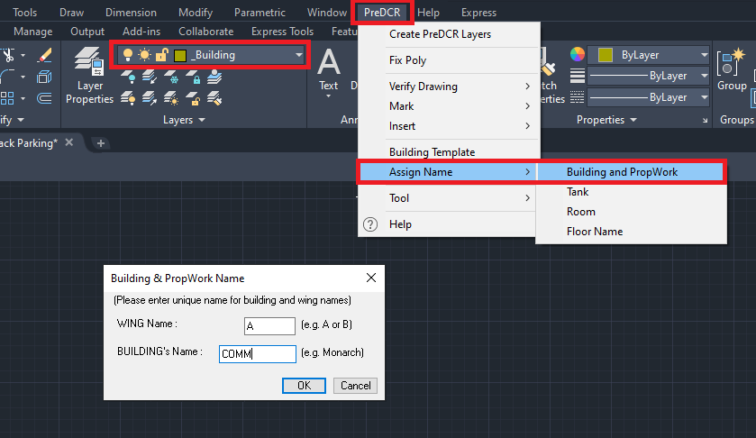
After completing the conversion proceed to the next tab of the PreDCr toolbar:

- How to Fix Poly?
This command is used once the complete drawing conversion is done. This tab will check all the polylines on the PreDCR layer and remove extra vertices found on polyline or duplicate entity. This command should be used (before verifying the drawing) every time you add any new entity in the drawing.

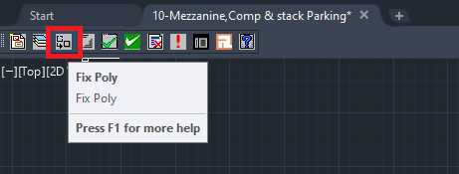

- How to Mark Margin?
- To Mark Margin:
Click on the ‘Mark Margin’ tab to open a dialog for mark margin.
In the dialog box:
Select ‘Front’Select from margin on site plan
Select ‘Side’Select both side margin on site plan
Select ‘Rear’Select rear side margin on site plan

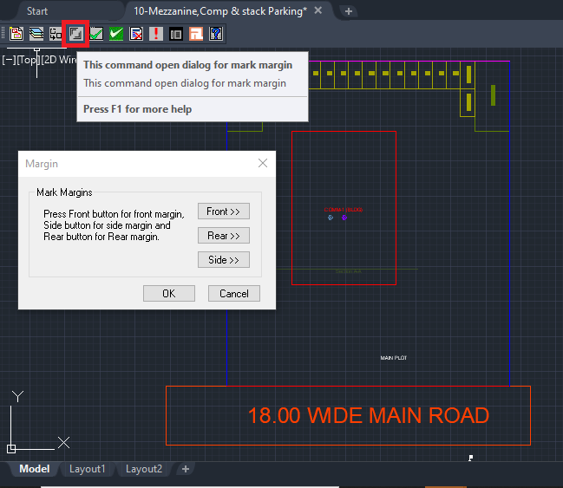
After clicking the mark margin system automatically creates the net plot and changes the marked margin layer colors.
- How to Verify close Poly?
This command will verify the current drawing as required by AutoDCR. It will verify that
LWPOLYLINE entities on the selected layers are closed and contain one text.
Shows ‘Select layer box’ select ‘Ok’.

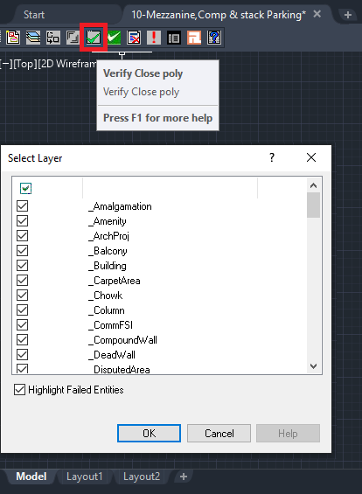
- How to Verify the Current Drawing?
This command is used to verify the layout and building-level objects in the current drawing plan.
- Check if these entities are drawn as closed LWPOLYLINE.
- Name text is given to all objects.
- Entities are placed exactly inside their parent objects (container).
- Naming conventions are followed properly.
In the "Verify All Drawing Dialog" you can select the layout or building objects to be checked. To view the result, press the OK button.
Select ‘OK’ in Entity not found list dialog box.

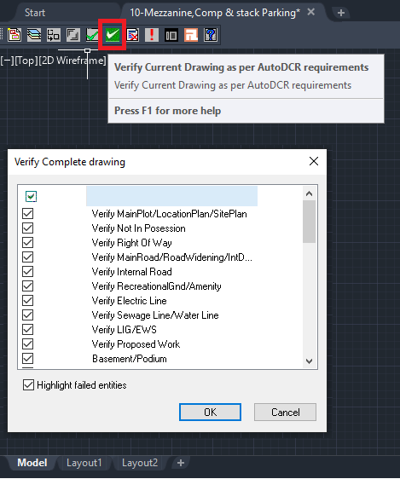
PreDCR will start checking all corresponding objects in the currently open drawing and then display the status as OK or list of failed objects with the reason of failing in the dialog as shown.

- How to view the ‘PreDCR Report’?
- Clikc on Show failed entity report.

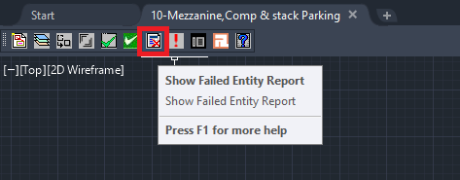

This command will generate the PreDCR report and having area details of the drawn entities in the drawing. All the verified and failing entities having Information will be shown in this Report.

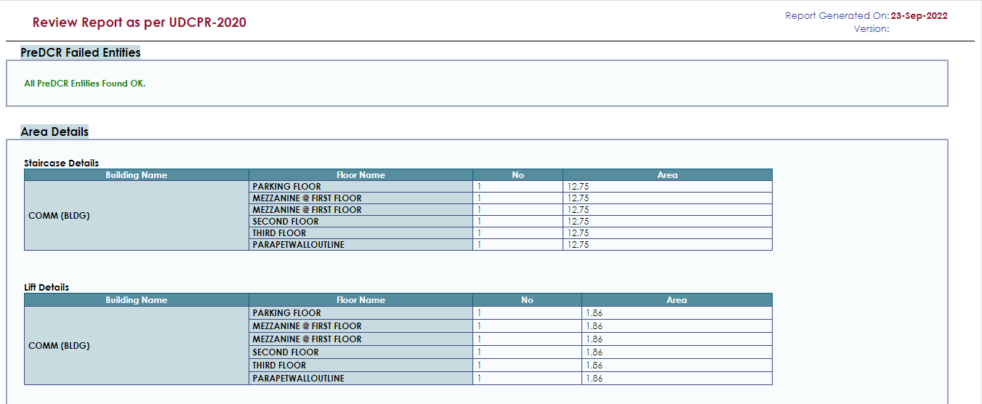

- How to use the ‘Show Objection List’ tab?
This command gives the list of all minimum required entities which are not there in your drawing. If all required entities found then it gives a message that minimum required entities are present in drawing.
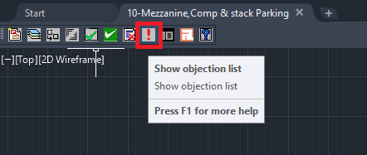
- How to map architectural layers with PreDCR MH layers?
- Click on ‘Layer mapping for current drawing’ tab
- This is to map the architectural layers with PreDCR layers.
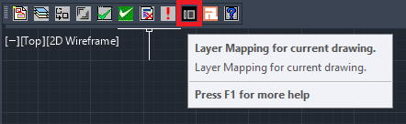
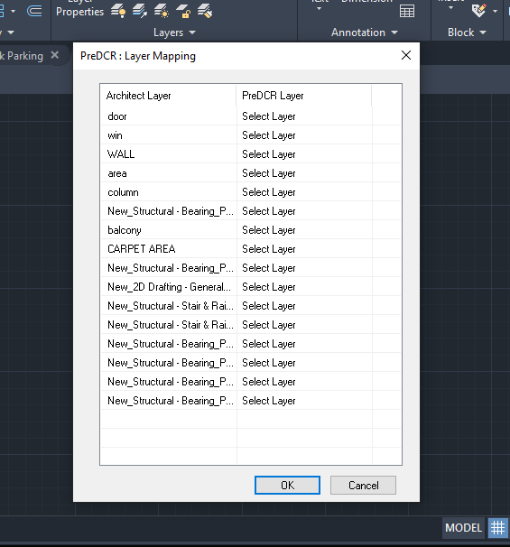
- How to view active help?
- Click on ‘Active Help’ tab for quick help regarding PreDCR layers.
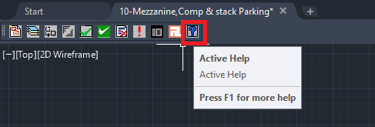

This the last page of the document.
Thank You.

